Lisavaird N.S.


Clonakilty, Co. Cork
(023) 88 34987
Email: office.lisavairdns@gmail.com
Facebook: Lisavaird National School
Website: www.lisavairdns.ie
- Our Class are broken down into the following groups:-
Infant Classes - Junior & Senior
Middle Classes - 1st, 2nd,& 3rd Class
Senior Classes - 4th, 5th & 6th Class

This may be subject to change

- Classes start at 9:10a.m.
- Finish at 1.50p.m. for Infants
- Finish at 2.50p.m. for all other classes.

N. B. Junior Infants go home at 12 noon for the first two/two & an half weeks of September.

- We have an electronic Roll Book which has to be completed by 10.30am each day.

- Children are collected at the gate or at the front door on wet days. If a child is going home early for some reason please knock at the classroom door and wait, rather than going straight in as this disturbs the class.

- Absences or notification of appointments should be communicated via the Homework Journal.
N. B. Under the Education (Welfare) Act 2000, schools are required to report if a child has had 20 or more absences.

- Parent – Teacher Meetings are usually held in the first term. If you need to speak to your child’s teacher outside of this, please contact the teacher in advance and make an appointment. This ensures that the teacher is prepared and can give you their full attention.

- Notes from teachers are put into your child’s Homework Journal. As younger children often forget about notes, please check the Journal every night when helping with homework. Please check homework each night and sign Homework Journal.

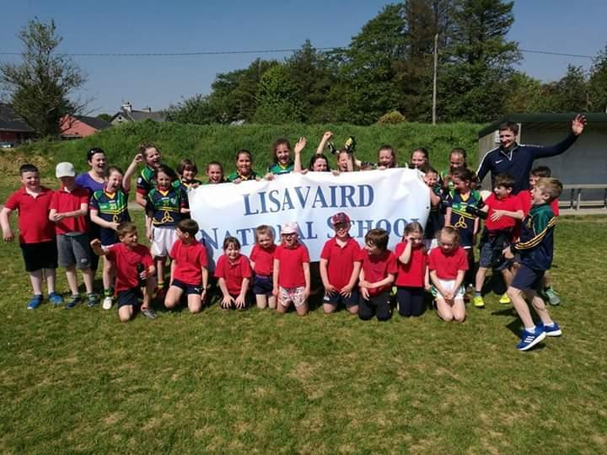

Children will have the opportunity to engage in extra curricular activities such as music, drama, craft, film making, coding, rugby, football etc. 2nd Class upwards go swimming. We also participate in Cork City Sports each June, as well as holding our own Sports Day. Students compete in local sports and art competitions as well as quizzes throughout the year

School Tours are usually held during the Summer Term. Pupils also go on Educational Field Trips e.g. areas of local interest.

- There are 11 subjects taught in all classes. These are Irish, English, Maths, History, Geography, Science, SPHE, Art, Music, Drama, PE and Religion.

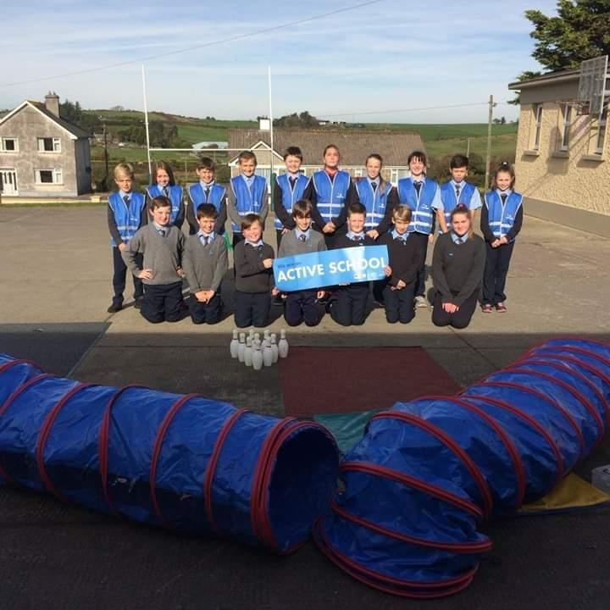

Staff
Kieran O’Donovan Principal
Kathleen Eady Deputy Principal
Fiona Deasy Class Teacher
Gerard O’Donovan Class Teacher
Deirdre O Brien Class Teacher
Hazel Hogan SNA
Rachel O’Donovan SNA & Secretary
Jonathan Carroll SNA

Uniform
Plain navy tracksuit top with sew on/iron crest, available to purchase from the school
Plain navy tracksuit pants
Light blue shirt/polo shirt

Parents Association
We have a very proactive Parents Association who work with the school to get the best possible education for all the pupils. Our Parents Association have organized many fun events for the children and have raised funds for activities and additional resources within the school. The AGM usually takes place in October and we would encourage you to attend as every association benefits from ideas and contributions of new members.

Primary Online Database POD
The Department of Education and Skills has developed an individual database of primary school children called Primary Online Database (POD). Schools are obliged to submit the following details about their pupils: name, address, date of birth, PPSN, gender and nationality. For further details please visit www.education.ie and click on POD.

Fáilte romhat agus roimh do pháiste.

Starting school will be the first big change in the life of your child. Up to this he/she has felt safe and secure with you in the home and family but now they are facing the wider world of classroom and school. This may seem a big step for someone so small but most children manage it without any great fuss or stress - and in fact take to it like ducks to water.

However, it is also a time when parents and teachers should take special care to ensure that the transition from home to school is as smooth as possible. If the child’s first experience of school is one of happy involvement, a very good foundation will have been laid for fruitful school years ahead.

It is important too, particularly during the first year that parents understand what the aims of the school are, as many may be expecting too much in the way of academic achievement.

We know from experience that parents are very anxious to help in any way possible. We have, therefore, included some ideas for the home, which should stimulate the child’s interest and nurture his/her desire to know more.

With these aims in mind we have put together this little booklet as a general guide for parents. It deals briefly with the period before your child comes to school and his/her introductory stage in Junior Infants.

We trust you will find it helpful and that your child will be happy and fulfilled with us.

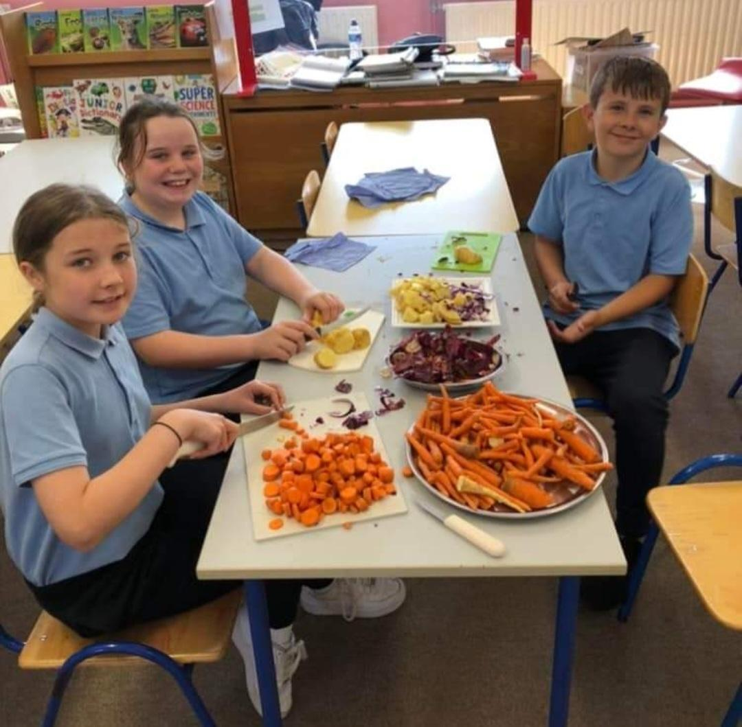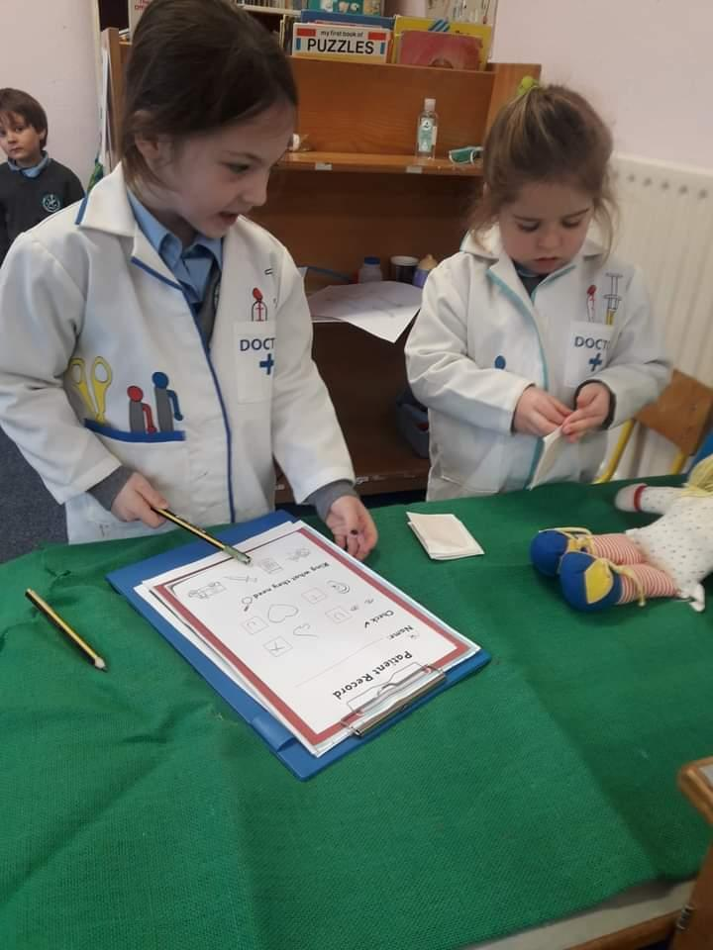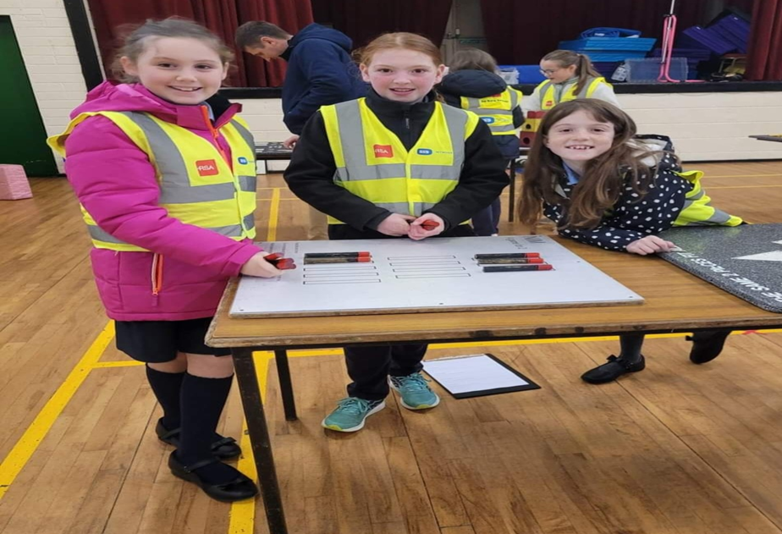

Getting Ready for Learning

Children are natural learners. They have an inbuilt curiosity and an eagerness to know more about everything – about themselves, about others and about the world around them. And they learn fast – but only when they are ready and their interest is aroused.

Because they come to us so young we must guard against putting pressure on them to learn what they are not yet ready for. Demanding too much too soon can switch a child off completely. At the same time we must cultivate readiness so that they can get moving as soon as possible.

The rates of progress of children can vary greatly. We try to give them an opportunity to move ahead at their own pace or as near to it as possible.

Our first year in school therefore, is mainly about settling in, relating to others, making friends, feeling happy and gradually getting used to the routine of the school. On the learning side the emphasis is on getting children ready for learning by –

- Developing their oral language and expression.
- Sharpening their senses, especially seeing, hearing and touching.
- Developing physical co-ordination especially of the hand and fingers.
- Extending their concentration span and getting them to listen attentively.
- Learning through play – the most enjoyable and effective way.
- Co-operating with the teacher and other children.
- Performing tasks by themselves.
- Working with others and sharing with them.
- Teaching each child to accept the general order, this is necessary for the class to work well.

Before Your Child Starts….

You should ensure that your child is as independent as possible - physically, emotionally and socially. If he/she can look after themselves in these areas they will feel secure and confident and settle in readily.

- It would help greatly if he/she is able to-
- Button and unbutton their coat and hang it up.
- Use the toilet without help and manage pants buttons
- Also encourage personal hygiene and cleanliness. Your child should know to flush the toilet and wash their hands, without having to be told.
- Use a tissue when necessary.
- Share toys and play things with others and “take turns”.
- Tidy up and put away their playthings.
- Remain contentedly for a few hours in the home of a relative, friend or neighbour. If they had this experience, then separation from their parents when starting school will not cause them any great anxiety.

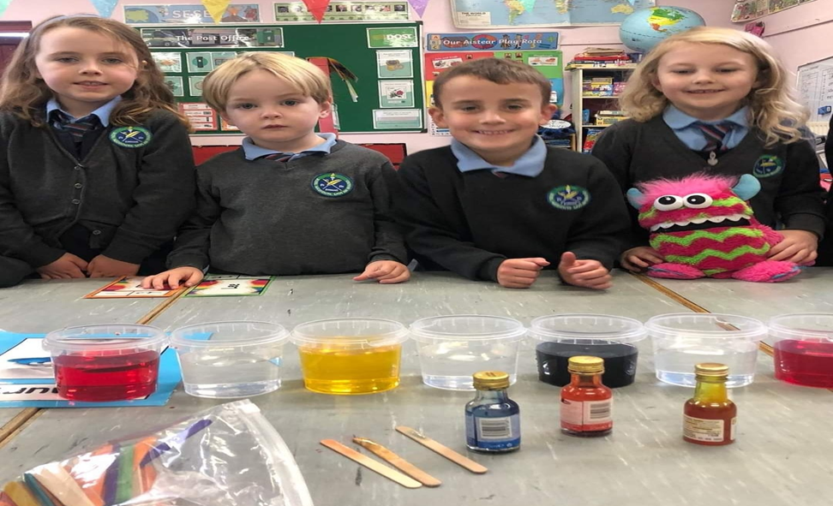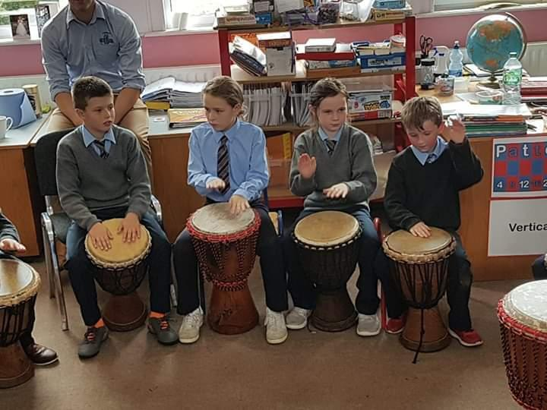

Preparing for the ‘Big Day’

The child’s first day at school is a day to remember for the rest of their life. You can help to make it a really happy one for them.

- Tell your child about school beforehand, casually, and talk about it as a happy place where there will be a big welcome for them and they will meet new friends.
- If you feel it would help, you could take them for a stroll to the junior classrooms and play area on an afternoon during June when the other children have gone home. Your child can browse around and become familiar with his new environment. On arrival you could drop in to meet the Principal with them and perhaps they could meet the teacher, as well.
- Your child will like to have their new uniform and new bag when they begin. These help your child identify more readily with the school and other children.
- Your child’s books will be taken from them on the first day of school and the teacher will hold on to them until such time as they are needed. This minimises books getting lost. Please have your child warned of this fact; in case they think they will never see the books again. All books/copies must be marked with your child’s name and readers must be covered. Your child will only feel important if they have something in their school bag, so perhaps you could buy a copy or colouring book for them, which they could use at home.

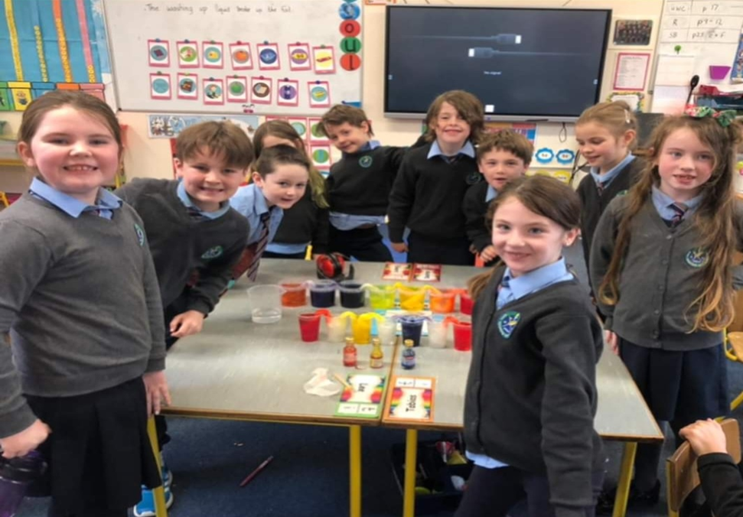

The Big Day
Coming In……
When you arrive at the classroom, be as casual as you can. Your child will meet the teacher and the other children and will be shown their chair.

Hopefully they will be absorbed in their new surroundings. So having assured them you will be back to collect them, wish them goodbye and make your getaway without delay.
Packed Lunches
Lunch is an important meal for school going children. It should provide one third of their recommended daily allowance of nutrients without being high in fat, sugar or salt. It should also provide dietary fibre (roughage).

The traditional packed lunch of milk and sandwiches is under attack from a range of convenience foods like crisps, sweets, biscuits, chocolate and soft drinks. Parents and teachers are concerned about this trend but some find it difficult to come up with popular healthy alternatives. We will ask you to encourage a healthy lunch right from the start. Also, please, only give your child something you feel they can easily manage to eat. Children are not normally very hungry at school, so a little snack will do.

A copy of the schools Healthy Eating Policy is available on request.
Start with the Basics
A healthy packed lunch should contain bread or an alternative, a savoury filling which provides protein, a suitable drink and some fruit and/or vegetables. Children are allowed to bring a small treat on a Friday such as a fun size bar or home baking.
A Word about Milk
Growing children should get approximately one pint of milk a day, or its equivalent as cheese, yoghurt or milk pudding. This ensures that they get enough calcium, which is essential for healthy bones and teeth. If a child does not drink a glass of milk at lunch, encourage him or her to have a carton of yoghurt or a small helping of cheese instead.
Going Home
- Be sure to collect your child on time. Children can become very upset if they feel they are forgotten.
- Keep out of view until the children are released.
- If at any time the collecting routine has to be changed ensure you tell the child and the teacher.
Handling an upset child
In spite of the best efforts of both teacher and parents a small number of children will still become upset. If your child happens to be one of them don’t panic. Patience and perseverance can work wonders.
As Time Goes on…
- School begins at 9.10a.m. To ease the child into the school routine we have a policy where Junior Infants go home for the first two weeks at 12noon (so no lunch). After that they go home at 1.50p.m. Please make sure that your child is collected at 1.50p.m.
- Get your child into the habit of being in good time for school from the beginning.
- Mid-morning break is at 11pm and lunch break is at 12.30pm.
- Children need plenty of rest after the effort and excitement of a day at school. You should ensure that they get to bed early and have a good night’s sleep.
- When they have settled in and hopefully, look upon school as a “home from home” do continue to show interest in your child’s daily adventures. Give them an ear if they want to tell you things.
- If your child’s progress is slow do not compare them adversely with other children while he/she is listening. Loss of self-esteem can be very damaging to children.
- He/she is not going to be a model of perfection all the time-thankfully. You should try to have patience with your child’s shortcomings and praise for their achievements.
- Children often “forget” or relay messages incorrectly, so please, check your child’s homework journal and bag each night for notes.
- You will receive a book list outlining the books and other bits and pieces your child will need for the year. This will also be placed on the school website when it is finalised.

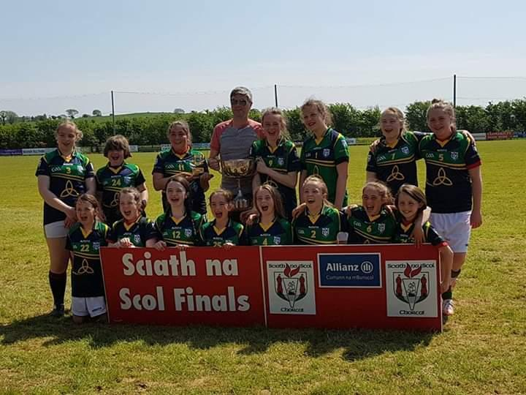

Some Important Areas of Early Learning
Developing his Command of Spoken Language.

It is important that the child’s ability to talk is as advanced as possible. It is through speech that he/she communicates their thoughts and feelings, their needs and desires, curiosity and wonder. If they cannot express these in words they will tend to remain silent and will often withdraw from the learning activity of the class. This can be the first sign of failure in the school system and must be remedied, if at all possible. That is why a lot of attention is given to language development in the first years of school.

You Can Help….
- Talk to your child naturally and casually about things of interest that you or things he/she may be doing-at home, in the shop, in the car, etc. Remember that all the time they are absorbing the language they hear about them. It takes them a while to make it their own and to use it for their own needs.
- Try to make time to listen when they want to tell you something that is important to them. But don’t always make them the centre of attention.
- Answer their genuine questions with patience and in an adequate way. Always nurture their sense of curiosity and wonder.
- Introduce them gently to the ideas of why? How? When? Where? If? etc. These demand more advanced language structures.
- They will have their own particular favourite stories that they never tire of hearing. Repeat them over and over again and gradually get them to tell them to you.

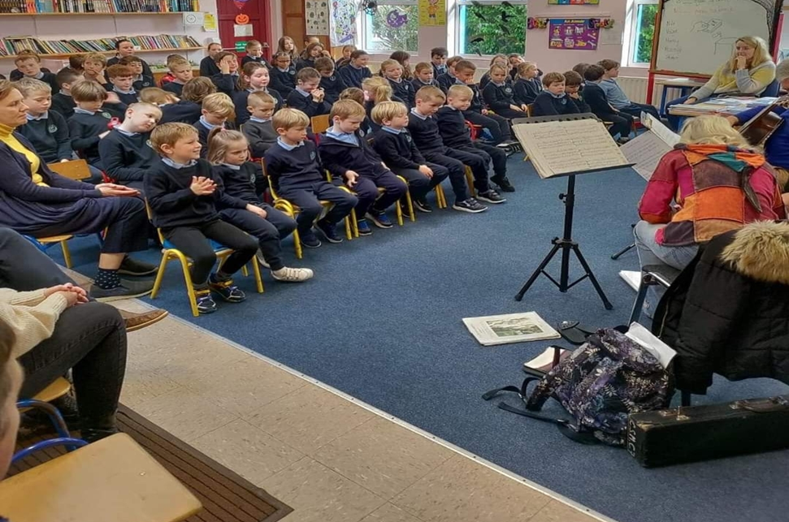

First Steps in Reading
Ability to read is the foundation for all future progress in our school system. However, learning to read is a gradual process and a lot of preparatory work must be done before a child is introduced to their first reader.

We very deliberately do not rush or push children into reading. We get them ready for it over an extended period. Reading is something to be enjoyed. It should never start as a chore for the small child.
You can help…
- Have attractive colourful books in the home.
- Read a variety of stories from time to time. They will get to associate these wonderful tales with books and reading.
- You must gradually convey to them that books are precious things. They must be minded and handled carefully and put away safely.
- Look at the pictures with them and talk to them about what they say.
- Read nursery rhymes. They will learn them off their own bat. Don’t try to push them.
- Above all, don’t push them with early reading. You may turn them against it for evermore.
- Remember that the teacher is the best judge of what rate of progress is best suited to each child.
- Sing the alphabet song with your child, so that they at least heard of the letters. If they know what each one looks like, all the better.
Understanding Maths
Maths for the small child has nothing to do with “sums” or figures or tables or adding and subtracting. These will all come much later. Maths is really part of the language he uses in understanding and talking about certain things in their daily experience e.g.

- Associating certain numbers with particular things – two hands, four wheels, five fingers etc.
- Counting – one, two, three, four, etc.
- Colours – black, white, red, green, etc.
- Prepositions (telling position) and their opposites: over/under, before/after, inside/outside etc.
- Matching/Sorting – objects of the same size/colour/texture/shape etc.
- Odd One Out – difference in size/colour etc.
- Understanding of these concepts comes very quickly for some children. For others it takes a long time. Be patient. You cannot force Maths understanding on a child.
But You Can Help…
- In the course of your ordinary daily routine in the home, in the shop, in the neighbourhood you should use suitable opportunities to casually introduce the Maths vocabulary referred to above. E.g. How many cakes? The glass is full/empty. We turn left at the lights.
- The child gets to understand Maths best by handling and investigating and using real objects. This has been their natural method of learning since they were a baby. This at times can be a nuisance but if it allows them to do the learning themselves, the final result is well worth it.

Gaeilge
All children enjoy learning another language besides their own language. They have no difficulty in picking it up because it fascinates them as another code of communication.
They are free of any hang-ups about Irish. Please try to encourage a positive attitude towards the language.
We would want the child’s parents to give every encouragement and help to the small ones in their efforts to acquire Irish. If they learn new words in school encourage them to use them at home. Use little Irish phrases or words now and again. Children are delighted to find out that their parents are into their new code as well.

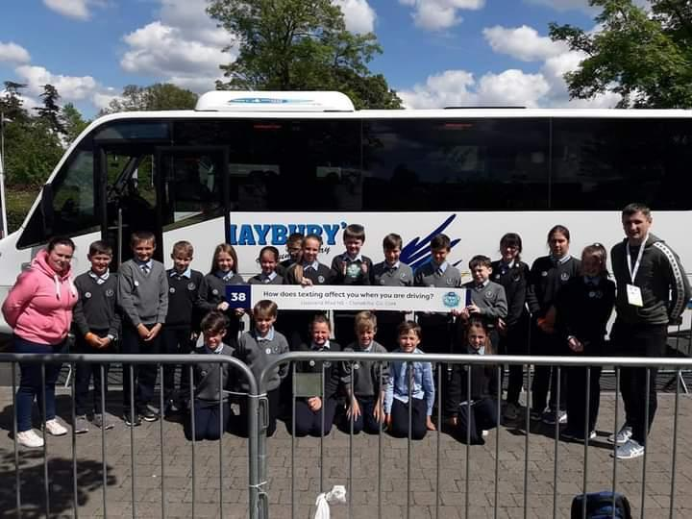

Getting Ready For Writing
Making letters on paper is not easy for the small child. They must learn to hold the pencil properly and make regular shapes. Their hand and finger muscles are only gradually developing at this stage.
You Can Help…
- Your child must develop the ability to get the hand and eye working together. This is very important. Get them manipulating toys like:
  - Jigsaws, Lego, beads to thread etc
  - Pleistocene (Marla) to make his own shapes
  - A colouring book and thick crayons
  - Sheets of paper that he can cut up with a safe scissors
- When they begin to use a pencil make sure that they hold it correctly at the start. It will be difficult to change this later.
- Your child may be making block letters at home even before they come to school. This is fine. But when they start making lower case letters at school you should try to get them to discontinue the blocks and practise his new system whenever they feel like it. Consult the teacher about this.
Other Areas of the Curriculum
The child in Juniors learns a lot through many other activities. Their general development is enhanced through Art & Craft, P.E., Music, Nature and Religious Education.
In regard to the last area, its moral and social aspects are covered right through the school day e.g. kindness to others, sharing with them, saying we are sorry, being aware of God through the beauty of nature etc.

The children learn their prayers and bible stories gradually. Again the child will benefit from practising at home what they have learned at school. They can then make their own contribution to the usual family prayers.
Social skills are very important. We encourage good manners at all times, please/thank you, addressing teachers properly, being courteous to fellow students and teachers. It is important to ask your child whom they played with at school and to ensure they aren’t alone. Also encourage mixing rather than being dependent on one friend only. Rough behaviour is totally discouraged in the playground. You will find a list of school rules and policies enclosed.

Teachers and Parents
At the early stages some parents meet the teacher a lot e.g. at collection times. However, if there is something in particular that you would like to discuss you can arrange to meet her/him at a time when you both can have a little peace and quiet.

Parting Thoughts
Our Hope
We are offering this Guide to Parents as a little practical help in dealing with the education of their children at the very early stages. We will be very happy if you dip into it from time to time and find something in it of value to you and your child. If you ever have any questions or concerns please feel free to contact the school and we will endeavour to address your issues promptly and professionally.

